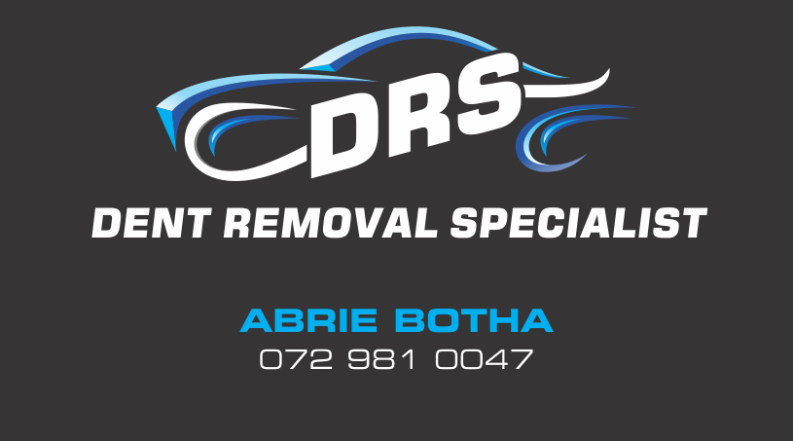

# ABOUT US

DRS Dent Removal Specialist is a company that offers Mobile Paintless Dent Removal, Hail Damage, Auto Detailing, Head Light Restoration, Mag and Rim Repairs, Minor scratch removal with reasonable prices, good quality and exceptional service.

We have qualified technicians operating mobile units and a workshop servicing the Western Cape.

We strive to have you as one of our clients and look forward to doing business with you.

**PAINTLESS DENT REMOVAL**

**Pressing Technique:**

Paintless dent removal is the art of using specially designed tools to remove dents without panel beating or spray painting. O ur qualified dent technicians have been trained to use these specialised tools to access the dents, whether on your doors, bonnet, roof, fenders or boot and massage the dent from the inside out until the damaged area is undetectable.

**Gluing Technique:**

At points that are inaccessible from the inside, a special adhesive is used to place small studs on the dent; these are then removed using a tension hammer without damaging the paint.

**Benefits of Paintless Dent Removal:**

* The original paint remains
* No value reductions when reselling the vehicle
* Repair method is recommended by manufacturers and insurance companies
* Fast and reliable repairs
* Environmentally friendly

What should you look for to determine whether the dent can be removed using the paintless dent removal system?

* Paintwork should not be damaged
* Dent should not be on a body line
* Dent should not be on the edge of any panel

MAG & RIM REPAIR

We offer a mobile Mag & Rim Repair service to the public. If a Mag is too badly damaged and can’t be repaired on the road we then take the vehicle to our workshop for thither assessment.

AUTO DETAILING

We only use the best products for your client’s vehicles and that is why we partnered with the best there is to offer MeGuiare’s. Their 4 in1 paint protecting has been proven to be the best in today’s market and we stand by their 1 year UV protection warranty. We remove industrial fallout to.

MINOR SCRATCHES

Minor scratches can be repaired on-site and we do offer a mobile team. We can mix paint to its natural colour on-site and apply it to your vehicle. We have a 24 month warranty on our workmanship and paint work. For the best finish and quality we prefer the vehicle to come in to our workshop. Mobile unit can only blend on plastic corners and not big open panels example bonnets and door and fenders are more likely to fade after time so we prefer to spry the hole panel..

HEADLIGHT RESTORATION

We remove all corrosion that has build up on your headlights after all these years, by sanding it down and buff & polishing it with the MeGuiars products and bring it back to its showroom quality finish and look.

BENEFITS FOR YOU

* Mobile service is on location within 24 hours
* Support of your team with experienced personnel
* Supplementation of your repair services for your clients, all from one source
* Estimates of the expected costs at an early stage using our calculation model
* professional claims processing and 5-year guarantee on the work carried out by us
* Satisfied clients, to ensure that your clients remain your clients
* All our work comes with a Lifetime guaranty

|  |  |
| --- | --- |
|  |  |

DRS PRICE LIST

| Service | Price Range | Conditions |
| --- | --- | --- |
| Paintless Dent Removal | R150 –R180 | Depending on the size of the dent and the labour timeline |
| Mag & Rim Repairs | R250 – R750 | Depending on the damage to the mag and the mag type (For instance a diamond-cut mag requires more time and products) |
| Auto Detailing | R650 | Small Vehicles  (Hyundai i10, i20, Yaris, VW Golf) |
| R850 | Medium Vehicles  (BMW 3 Series, Mercedes C-Class, Audi A4, VW Jetta) |
| R1350 | Large Vehicles  (Bakkie, SUV, Toyota Fortuner, Mitsubishi Pajero) |
| Minor Scratches | R550 minimum | All scratches are different therefore the price is quoted per case |
| Headlight Restoration | R150 per light |  |